|  |
| --- |
| *Ahsanullah University of Science & Technology*logo.jpgDepartment of Computer Science & Engineering |
| Event Planner |
| Software Development III (CSE 2200)  Report on Final Project |
|  |
|  |
|  |

**Submitted By:**

**Tajbia Hossain 16.01.04.008**

**Humaira Zahin Mauni 16.01.04.012**

|  |
| --- |
|  |

**Objective:**

The event planner is a simple, versatile application that will help us organize our schedule on a weekly basis. It will be designed to keep track of any kind of event- be it social, educational, or work related- with ease. The application will consist of a colorful, timetable-style interface of the entire week where each event is color-coded and categorized by time.

**Features:**

The app will open in a tabular form containing grids according to days and working times. Each event is created via user input and physically occupies one or more aforementioned grids.

Each event will be able to store the following information:

1. Name of the event
2. Type of the event: Every type will be color-coded to differentiate between the following fields:
3. Work
4. Educational
5. Personal
6. Location: place where the event will be taking place
7. A checklist of tasks associated with or leading up to the event
8. Whether the event has passed/been completed
9. Notifications for events

More features may be added to the application later to improvise the application.

Optional or additional features for the app are mentioned below.

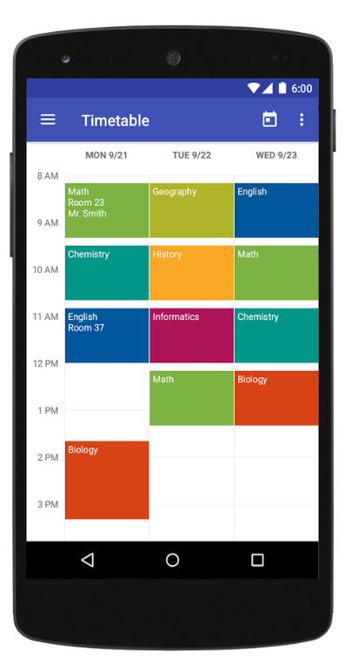

Fig:- The application will have a similar layout to the model shown above

**Additional Features:**

The additional features are the optional features that might be added later during the development:

* Inclusion of voice memos into events
* Inclusion of pictures related to the events
* Inclusion of text files related to the event
* Events also categorized from high to low priority
* Notification/Alarm/Timers to certain events and tasks
* Widget of app

**Timeline:**

The timeline for the project development is set according to the weeks in the semester.

**WEEK 5:** Project Proposal submission

Layout: Timetable/main page basics (Checkpoint)

**WEEK 6:** Layout: Development of Timetable layout

**WEEK 7:** Layout: Event creation mockup/basics (Checkpoint)

**WEEK 8:** Layout: Development of event layout

**WEEK 9:** Layout: Development of event layout

Database: event database basics (Checkpoint)

**WEEK 10:** Database: Storing and accessing data for each event

**WEEK 11:** Database: Storing and accessing data for each event (Checkpoint)

**WEEK 12:** Database: Displaying data for each event in main page/Timetable

**WEEK 13:** Improvisation on the created application, final checkpoint (Checkpoint)

**WEEK14:** Final Project Submission